CS4246 PROJECT REPORT

One Peer ExpoComm on Pursuit and Battle
One-peer ExpoComm learned all six MAgent configurations. Pursuit ended at 67.39 to 86.67 evaluation return, and Battle ended at 85% to 100% red-team win rate. The 42-agent Battle run fluctuated substantially during training and closed below its own recent average.

Experimental setup
Each configuration used training seed 0, a nominal budget of 5.05 million environment steps, and 100 test episodes at roughly 50,000-step intervals against a pretrained opponent. The exports identify ExpoComm_one_peer with one_peer enabled. The 5,000-episode replay buffer differs from the 2,000 episodes in the paper’s Table 2. Hidden size 64, discount 0.99 and batch size 32 match its MAgent settings [1].

Evaluation results
Table 1. Pursuit evaluation return. SD describes variation across test episodes.
Configuration | Agents | Final mean ± SD | Last 5 mean | Paper Fig. 4
Pursuit 45 | 25 | 86.67 ± 9.86 | 85.81 | ≈83
Pursuit 60 | 45 | 74.17 ± 7.58 | 73.45 | ≈80
Pursuit 70 | 61 | 67.39 ± 6.06 | 64.50 | ≈63
Table 2. Battle evaluation win rate for the learned red team.
Configuration | Agents | Final win rate | Last 5 mean | Paper Fig. 4
Battle 25 | 20 | 100% | 93.0% | ≈80%
Battle 35 | 42 | 85% | 92.4% | ≈80%
Battle 40 | 64 | 100% | 100.0% | ≈87%
Paper values are approximate right-edge readings of the solid red one-peer curves in Fig. 4, which aggregate five training seeds. Each local row represents one training seed. The last-five mean summarizes recent checkpoints within that run.

Why one peer can work
The paper’s graph rotates each agent’s peer through power-of-two offsets. The resulting topology uses N inter-agent links per step and has logarithmic dissemination diameter. A recurrent message aggregator retains information across steps, and an auxiliary objective grounds messages in global state on MAgent. This architecture explains how one peer per step can provide broad reach over time [1, §§3.1–3.3].
[1] X. Li, X. Wang, C. Bai, and J. Zhang. Exponential Topology-Enabled Scalable Communication in Multi-Agent Reinforcement Learning. ICLR 2025. arXiv:2502.19717.

Adversarial Pursuit
The 25-agent run finished highest at 86.67. The 61-agent run finished at its best observed evaluation, 67.39, above its last-five mean of 64.50. Compared with the paper’s one-peer endpoints, the local 25- and 61-agent runs finished higher and the 45-agent run finished lower.
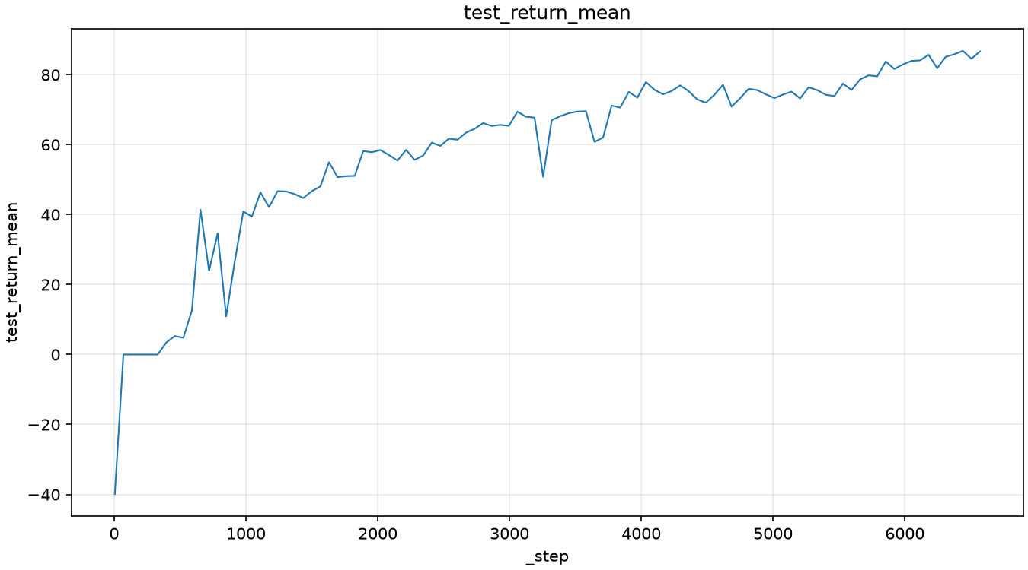
Figure 1a. 25 predators, 45 × 45 map, run 7oohgveb.
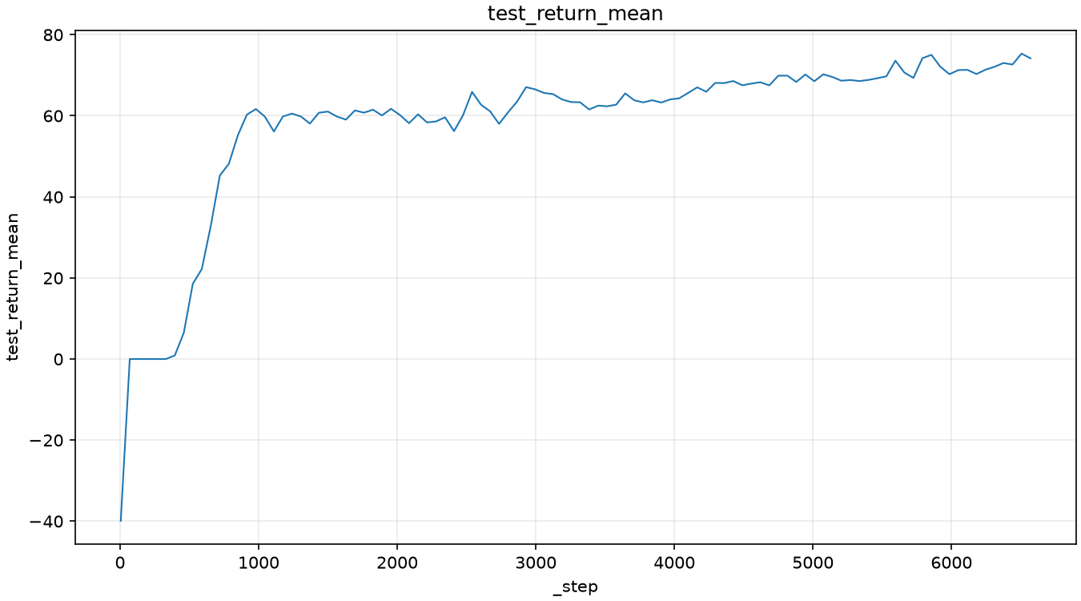
Figure 1b. 45 predators, 60 × 60 map, run lky5a2xa.
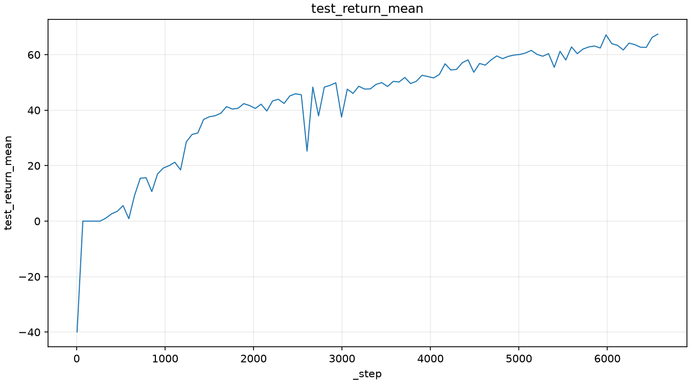
Figure 1c. 61 predators, 70 × 70 map, run 8vis0wl2.
Source for all panels is the exported test_return_mean graph. The horizontal axis shows the W&B history index (_step). The paper plots environment timesteps.
The paper’s 61-agent visualization shows trained predators trapping prey at the boundary and tagging repeatedly [1, Fig. 9]. That behavior offers a plausible explanation for high return. The exported curves quantify return and leave the local agents’ behavior to be verified from trajectories.

Battle
The 64-agent team won every episode in each of the final five evaluations. The 20-agent team reached 100% at the final evaluation and averaged 93.0% across the last five. The 42-agent team ended at 85%, below its 92.4% last-five average.
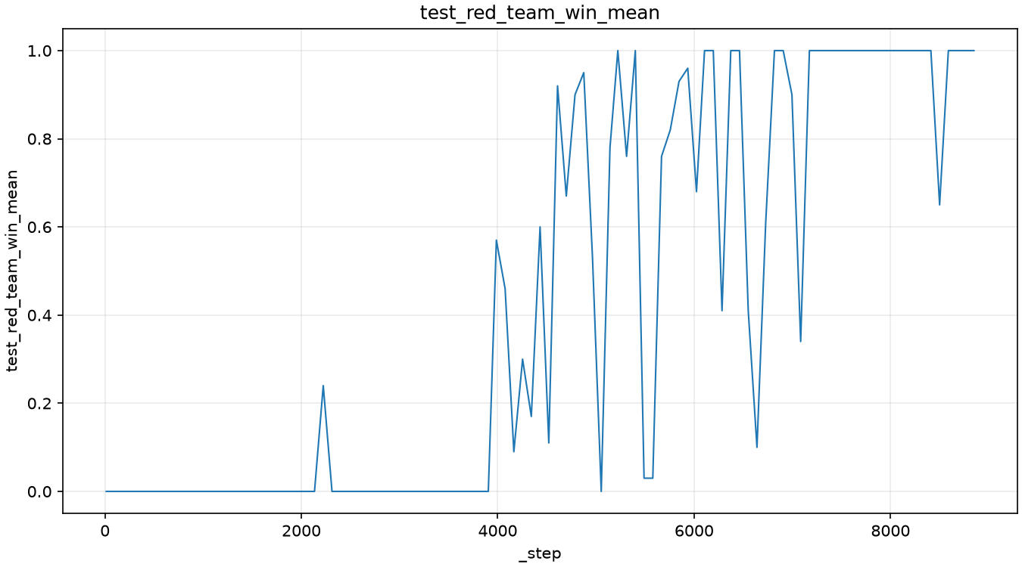
Figure 2a. 20 learned agents, 25 × 25 map, run tdltdzof.
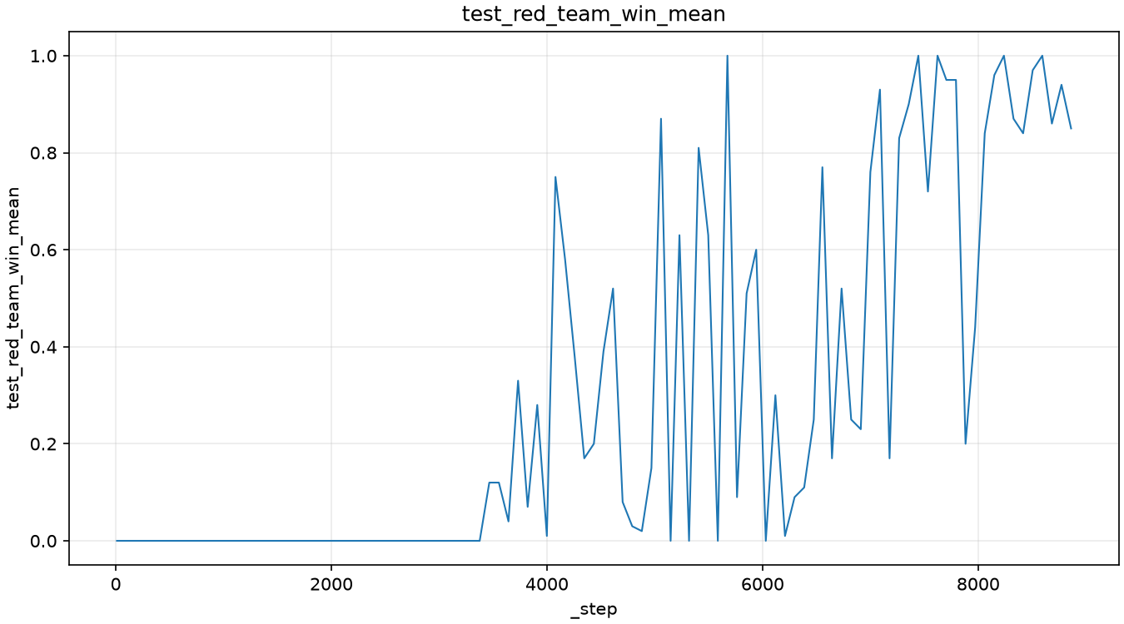
Figure 2b. 42 learned agents, 35 × 35 map, run hjv89i01.
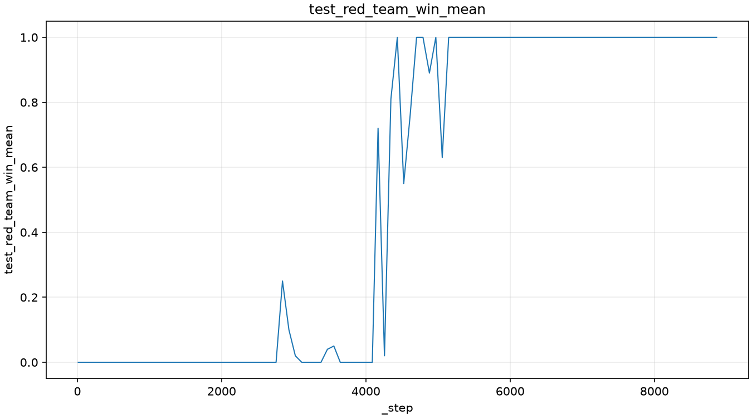
Figure 2c. 64 learned agents, 40 × 40 map, run 68wgbec8.
Source for all panels is the exported test_red_team_win_mean graph. Win rate is shown as a fraction and the horizontal axis is W&B _step.
The paper reports strong one-peer transfer in Battle under a small communication budget [1, Fig. 5]. The curves here measure play at the training team size against a fixed opponent. Transfer to larger teams and the contribution of communication would require separate evaluations.

